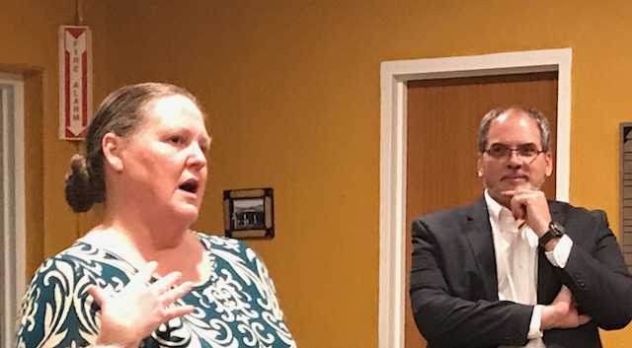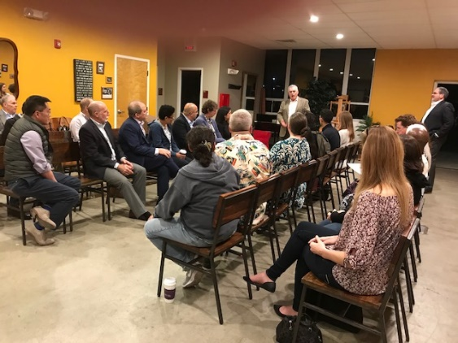

The Board of Trustees Meets at Chaffey College:
The IFMA Foundation Dream Continues to Come True
Meet the woman in the left photo who is caught speaking to the group of people on the right. She is the most energetic Mrs. Trina Lujano, a student in the Facility Management (FM) program offered for the second semester at Chaffey College and President of the IFMA Student Chapter, and Jeff Tafel, the Executive Director of the IFMA Foundation. Trina, an ex-process server for 18 years, is so excited about her newly discovered career journey in FM she convinced her husband to take the Project Management course also offered in the School of Business and Applied Technology. That evening she had even invited her son to discover the world of FM in the hope he would also catch the FM “bug” and sign up next semester for the program she is taking. None of the dozen students in the room had ever heard of FM before Chaffey College offered a course and lured them into this new profession by the fact there were so many jobs available in the Southern California region at generous salaries.
Jeff is smiling because he is so delighted watching her address the students and the IFMA Foundation Board of Trustees in this evening meeting of the newly forming IFMA Student Chapter. Jeff and the Foundation have been working on creating this first pilot of the Global Workforce Initiative (GWI) since he, the President and CEO IFMA (Tony Keane), IFMA past board chairman Mike Feldman, two IFMA Foundation Trustees (Joe Archie and Nancy J. Sanquist) and an outside economic developer (Pat Mckee) met three years ago at a retreat at Milliken Headquarters in South Carolina to create an initiative to actively make “FM a Career of Choice.” This evening the Foundation Board of Trustees faced the students to answer any questions they had about the FM profession and give insite to the learning they are doing in the course taught by an IFMA Fellow and long time FM professional, Phyllis Meng (who also teaches at UC-Irvine).
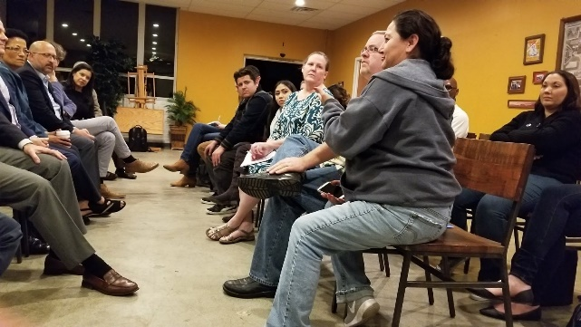
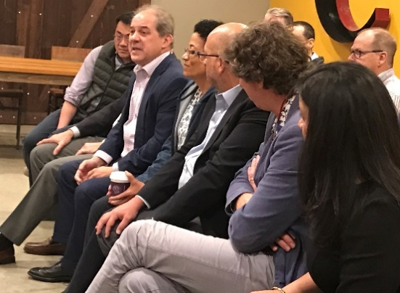
The IFMA Foundation Board of Trustees offering sage advice to some of the most recent individuals to make FM their career of choice

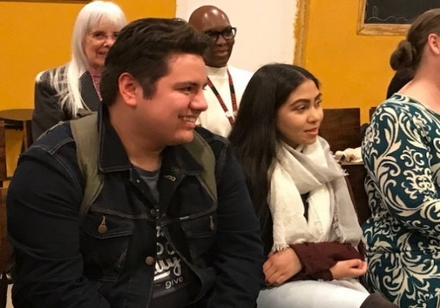

Students listening while program instructor Phyllis Meng and Dean Vanessa Thomas listen from behind.

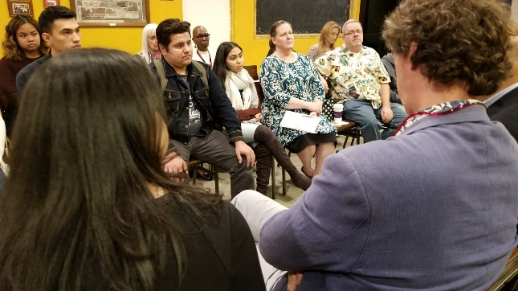
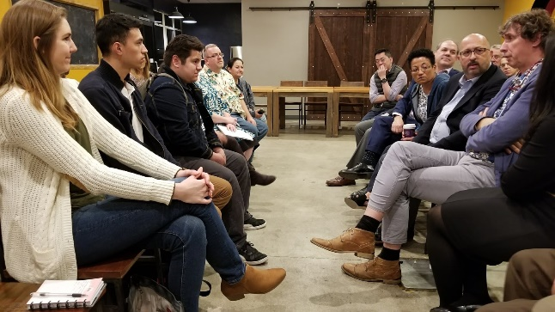

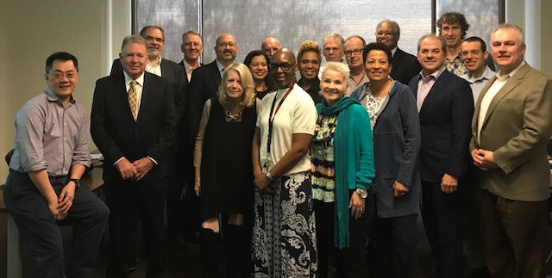
Earlier in the day this photo was taken of this illustrious group of individuals – members of the IFMA Foundation Board of Trustees, the California Community College System, and Chaffey College meeting in a classroom located in the shadows of the bottom of the mountains in San Bernardino on the Chaffey main campus. They had come together to realize a dream that some of them had three years ago and they had hoped would actually come true. With them are some of the key players to the Chaffey College GWI Project:
- Jim Caldwell (2nd from left in front) who is the Statewide Director and Sector Navigator for Energy Efficiency and Utilities at the California Community College System. Jim has been involved with the GWI since the IFMA Foundation contacted Mary Jane Ohlasso, Chief Business Officer for the County of San Bernardino about the initiative who immediately involved Jim. He, along with Vanessa and Joy, are the key players in making this dream come true at Chaffey College.
- Vanessa Thomas (4th from the left) is the head of Small Business, Entrepreneurship, Business and Management in the School of Business and is the champion for the FM program at the main campus.
- Joy Haerens (5th from the left) is the Dean of the School of Business and Applied Technology and embraced the initiative from the very first meeting along with Vanessa and is a passionate supporter. She told the group that GWI was “amazing work” and thanked the Foundation Board for inspiring the college to transform the way they can introduce a new course in a record time. She said they did so in response to the need for the industry to have FM skills as quickly as possible to ensure a trained workforce for the profession.
- Dr. Shannon is poking his head in the back of the group, 2nd from the right, and is the President of Chaffey College since 2007. He addressed the Board of Trustees and mentioned that programs like the GWI are “changing the higher education landscape.”
This is latest step in what the Foundation hopes are many GWI programs, not only in Southern California and the state-wide community college system, but all over North America and the planet. Global Workforce Initiatives are sprouting up in Texas, Maryland, Massachusetts, Tennessee, New York and even Hong Kong where the IFMA Foundation HK Ltd. Is being formed. By working on this initiative, the IFMA Foundation has gone from a scholarship granting non-profit to a major force behind creating opportunities at every stage of the FM career path including life-long learning to make FM a Career of Choice. The IFMA Foundation dream continues to evolve and grow – exemplified at Chaffey College as Trina talked that evening about how she is transforming herself, and maybe even her entire family, into productive and energized facility management professionals.

Nancy Johnson Sanquist, VP of Global Strategic Marketing, Planon B.V.; IFMA Fellow; IFMA Foundation Board of Trustees Vice-Chair; AIA Associate; nancy.sanquist@planonsoftware.com

